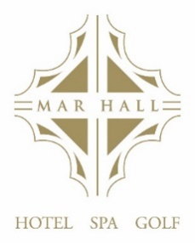

A LA CARTE

Baked Sweet Potato and Harisa Soup
Served with Freshly Baked Bread
£8.50
Pan Seared West Coast Scallops with Tomato, Roast Cauliflower and Chorizo Jam
£14.95
Smoked Salmon and Caper Salsa served with Oatcakes
£8.95
Chicken Liver Parfait served with Red Onion Chutney & Toasted Brioche
£8.95
Oven Baked Goats Cheese served with a Beetroot Salad
£9.50

oOo

Pan Roasted Fillet of Beef, Grilled Tomato, Flat Cap Mushroom, Chips and Peppercorn
Sauce
£39.95
Confit Lamb Shoulder, Douphinouse Potato, Carrots, Cabbage & Bacon
and a Red wine Jus
£27.50
Sea Trout, Parmesan Risotto served with Sundried Tomatoes and an
Almond Dressing
£26.95
Roast Gressingham Duck Breast, Burnt Aubergine, Sweet Potato, Fennel & Kohlrabi
£28.50
Potato Gnocchi with Mediterranean Vegetables in a Tomato Sauce
£21.95

Sides - £5.00
Chips
Onion rings
Seasonal Vegetables

May contain traces of Nuts

DESSERTS

Classic Creme Brulee
£8.95
Baileys Irish Cream 50ml
£7.95

Roast Peach served with Crème Fraiche with Blueberrys
£8.95
Sunset Mai Tai
£10.50

Five Spice Apple Crumble & Vanilla Ice Cream
£8.95
Bramble
£10.50

Sticky Toffee Pudding with Vanilla Ice Cream
£8.95
Espresso Martini
£10.50

Hand-Selection of Cheeses with Oatcakes and Red Onion Chutney
£12.95
Port LBV 50ml
£5.50

oOo
SPECIALITY COFFEES

Amaretto Coffee - £8.50
Baileys Coffee - £8.50
Gaelic Coffee - £8.50
Hot Toddy - £8.50
Irish coffee - £8.50
Baileys Hot Chocolate - £8.50

